DEALS TO HOLLYWOOD, FL

Looking for things to do in Hollywood, FL? Just south of Fort Lauderdale, Hollywood is a wonderful place to dig your toes in the sand. Book a trip to Hollywood, FL via Fort Lauderdale-Hollywood International Airport on Virgin America. Live it up at 35,000 feet with WiFi, on-demand entertainment, and more on every flight.

(MARKET IMAGE HERE)

Find Deals From These Cities

INSERT FARE GRID FROM / TO Version (if available!)

   
Top Things To Do in Hollywood, FL

When you’re not taking a leisurely stroll along the 2½-mile broadwalk (no, that’s not a typo) or relaxing on its beautiful beach, check out some of these fun activities during your stay.

* Spend an afternoon or evening at Arts Park. This park features ten acres of lush green space, making it a perfect place to go for a jog, have a picnic or take the kids to play. Try to visit during one of the many year-round festivals and cultural events that take place here - and don’t forget to bring some lawn chairs or a large blanket!
* Take a break and cool off in the fountain at Charnow Park.
* Hungry for pizza? Head to Mauro’s Pizza for a truly humongous (and delicious) slice.

Travel Tips and Resources

[Must-Dos in Hollywood, FLhttp://www.tripadvisor.com/Attractions-g34296-Activities-Hollywood_Florida.html](http://www.tripadvisor.com/Attractions-g34296-Activities-Hollywood_Florida.html)

[Hollywood, FL Hotelshttp://www.tripadvisor.com/Hotels-g34296-Hollywood_Florida-Hotels.html](http://www.tripadvisor.com/Hotels-g34296-Hollywood_Florida-Hotels.html)

[Hollywood, FL Restaurantshttp://www.tripadvisor.com/Restaurants-g34296-Hollywood_Florida.html](http://www.tripadvisor.com/Restaurants-g34296-Hollywood_Florida.html)

[Hollywood, FL Shopping Guidehttp://www.10best.com/destinations/florida/fort-lauderdale/hollywood/shopping/downtown-hollywood](http://www.10best.com/destinations/florida/fort-lauderdale/hollywood/shopping/downtown-hollywood)

[Hollywood, FL Nightlife and Entertainmenthttp://www.visithollywoodfl.org/dining_nightlife.aspx](http://www.visithollywoodfl.org/dining_nightlife.aspx)

[Hollywood, FL Travel Tipshttp://www.fodors.com/world/north-america/usa/florida/fort-lauderdale-and-broward-county/travel-tips](http://www.fodors.com/world/north-america/usa/florida/fort-lauderdale-and-broward-county/travel-tips)

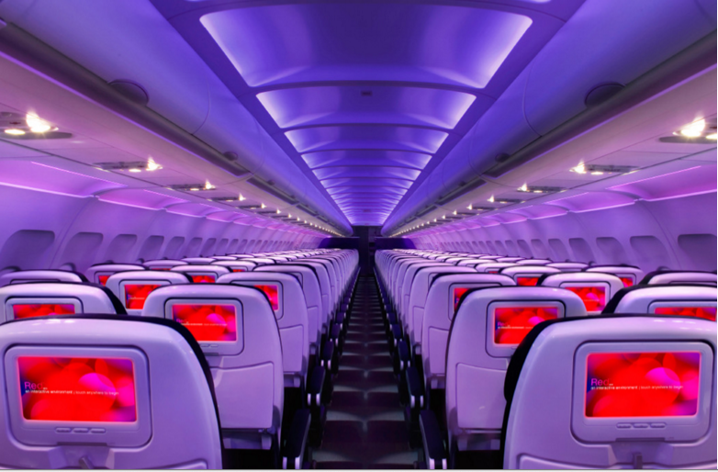

Main Cabin Main Cabin Select First Class

(add links to Cabin Class Pages)

Ready. Set. Fly.

Book your Mood-lit Ride to Hollywood, FL.

When researching flights to Hollywood, FL, you’ll find that Hollywood is served by Fort Lauderdale-Hollywood International Airport. When planning your trip, book your flight to Fort Lauderdale with Virgin America to ensure you have the best in-flight experience from beginning to end. You’ll find that we don’t miss any details, big or small. From our comfortable mood-lit cabins and custom-designed leather seats, to our on-demand entertainment and on-demand food ordering - among other luxuries - flying with us is a next-level experience.

Take a Virtual Tour

Add Terms & Conditions